**Experiment Name :** **Installation of Linux Mint 17**

**Aim and Objective:**

1. To learn about Linux Mint 17 Setup.

2. To learn about all the procedure. .

3. To perform all the task carefully.

**Experiment Setup:**

Steps are given below:

#### **Step 1: Booting Computer with Linux Mint 17 installation media.**

Booting computer with Linux Mint 17 installation media with USB. It will display below After booting from installation media it will display the below screen.

#### **Step 2: Clicking the ‘Install linux mint’ icon.**

Clicking **install linux mint icon** to install Linux Mint 17 on my system.

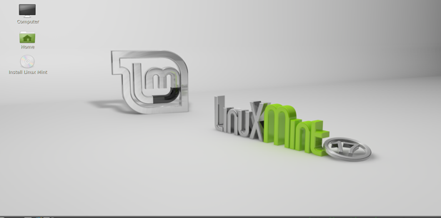

**Step 3: Preparing to Install “Linux Mint 17”.**

Verifying HDD Space and network connection. Hitting **Continue** button to move forward.

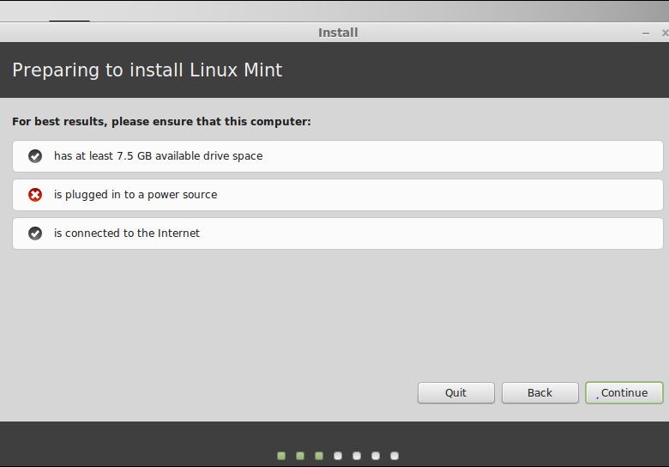

#### **Step 4: Installation Type**

This step is important one but simple. For **Fresh** installation choose first option **Erase disk and install Linux mint** as it will erase hole disk and create partition table automatically then move forward. If i choose fourth option **Something else** and it will also erase hole disk but need to create partition table manually by myself then hit **Install Now** button.

[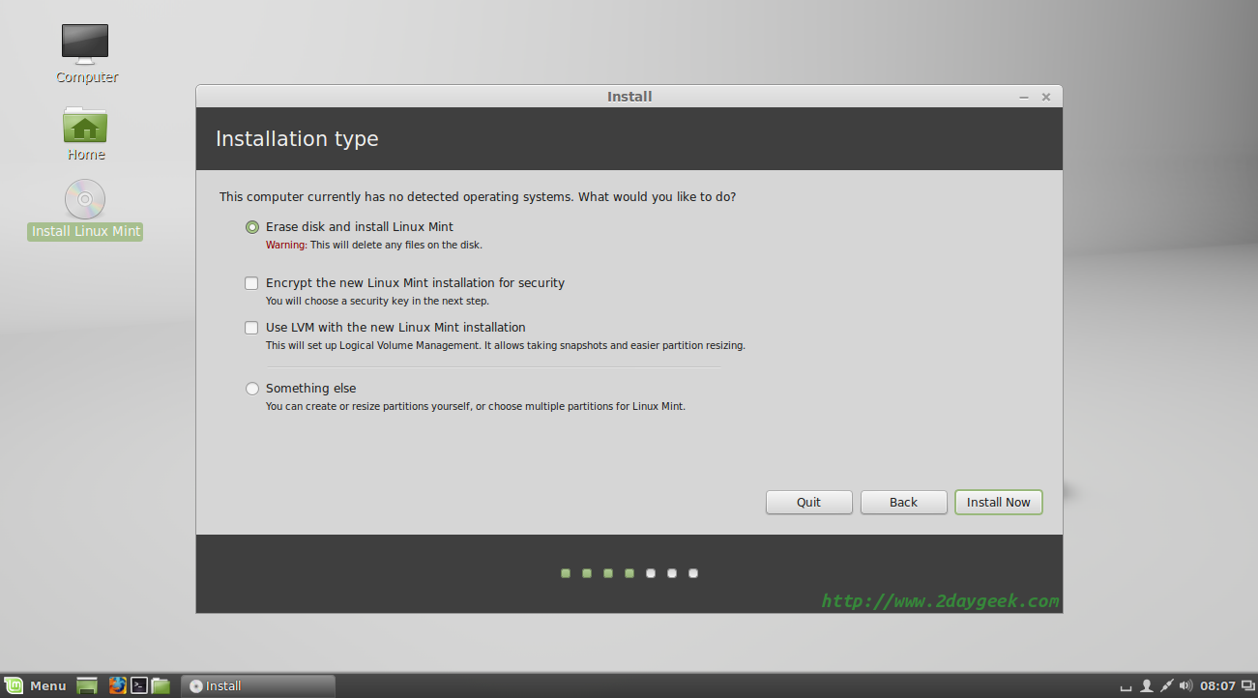](https://www.2daygeek.com/wp-content/uploads/2014/08/linux-mint-17-qiana-cinnamon-desktop-installation-steps-with-screenshot-6.png)

**I’m choosing first option and hit Install Now**

**Step 5: Select region**

Here im selecting the ‘Dhaka’ region . And then im pressing the continue button.

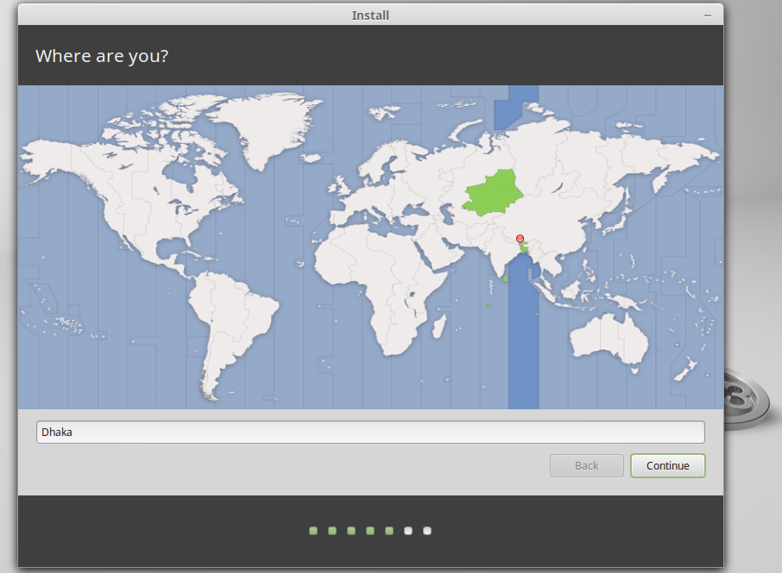

**Step 6: Keyboard layout Selection**

Now I’m choosing my Keyboard layout here and then hitting **Continue.**

[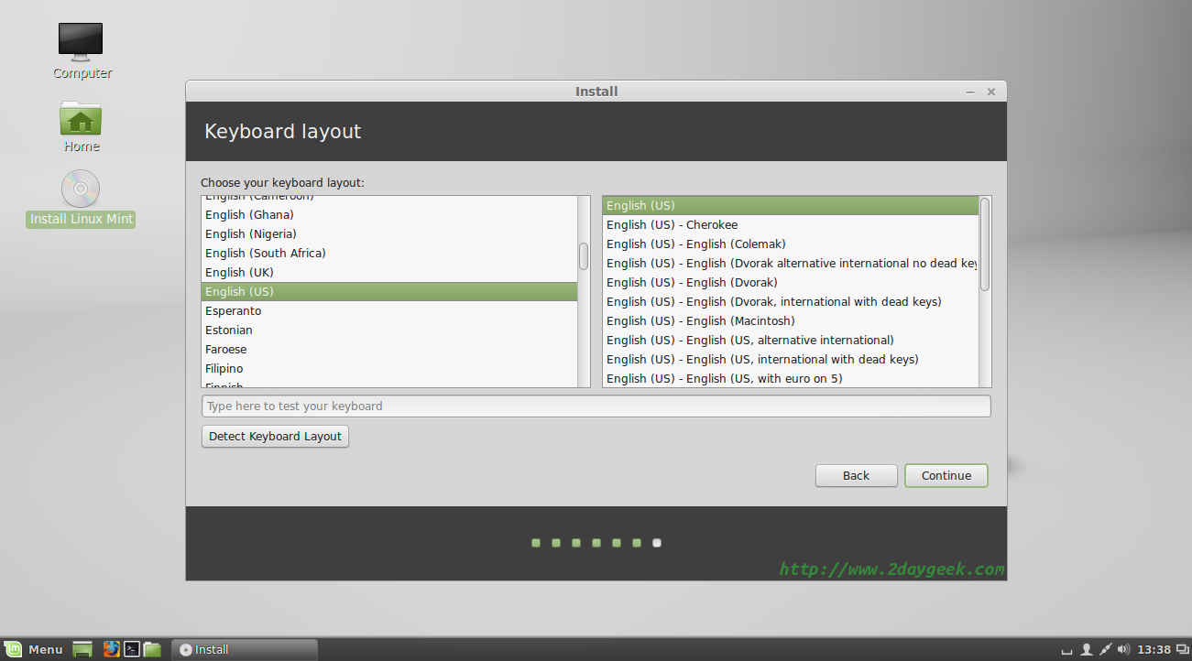](https://www.2daygeek.com/wp-content/uploads/2014/08/linux-mint-17-qiana-cinnamon-desktop-installation-steps-with-screenshot-8.png)

#### **Step 7: Installation initiated**

Linux mint Installer now copying all the system files to the hard disk.

[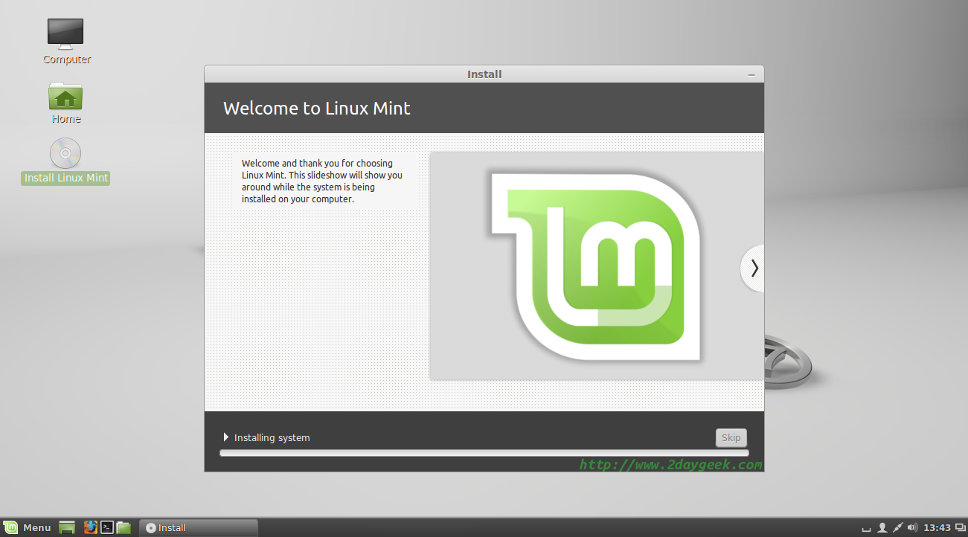](https://www.2daygeek.com/wp-content/uploads/2014/08/linux-mint-17-qiana-cinnamon-desktop-installation-steps-with-screenshot-10.png)

#### **Step 8: Installation process is going on**

Linux mint 17 Installation process is going on and it will take a while to complete the installation

[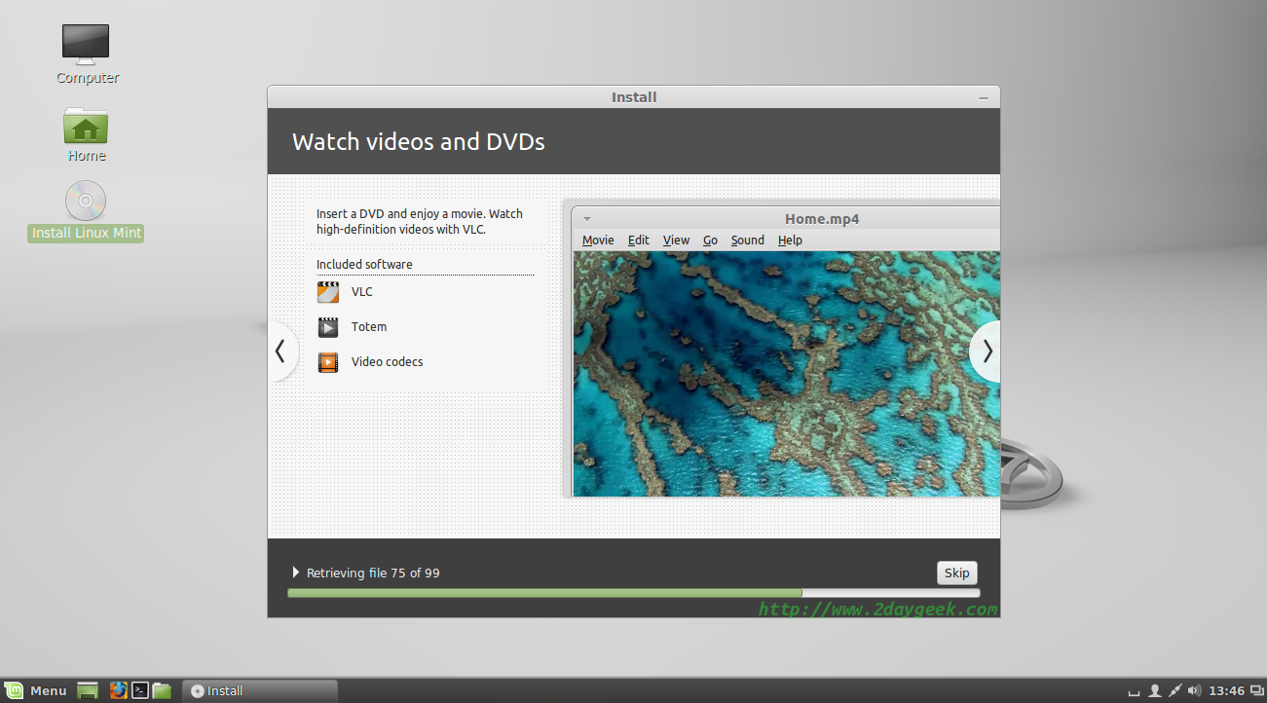](https://www.2daygeek.com/wp-content/uploads/2014/08/linux-mint-17-qiana-cinnamon-desktop-installation-steps-with-screenshot-11.png)

#### **Step 9: Installation got Compleated.**

Now, installation got completed and Remove your installation media then hit **Restart Now** button.

[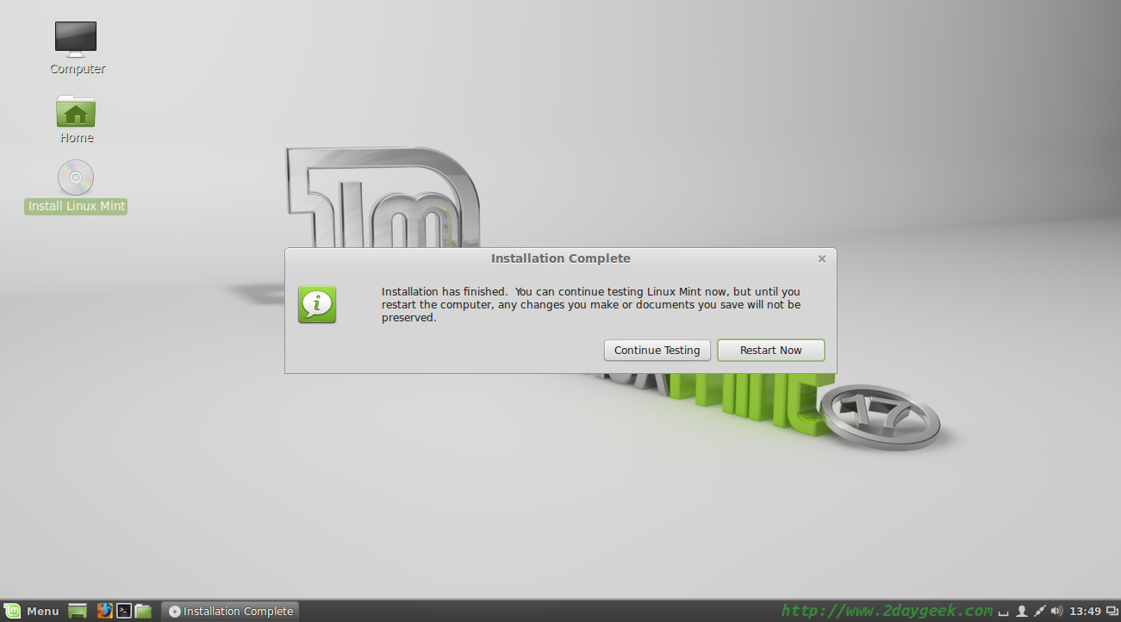](https://www.2daygeek.com/wp-content/uploads/2014/08/linux-mint-17-qiana-cinnamon-desktop-installation-steps-with-screenshot-12.png)

**Step 10: Log in to Linux Mint.**

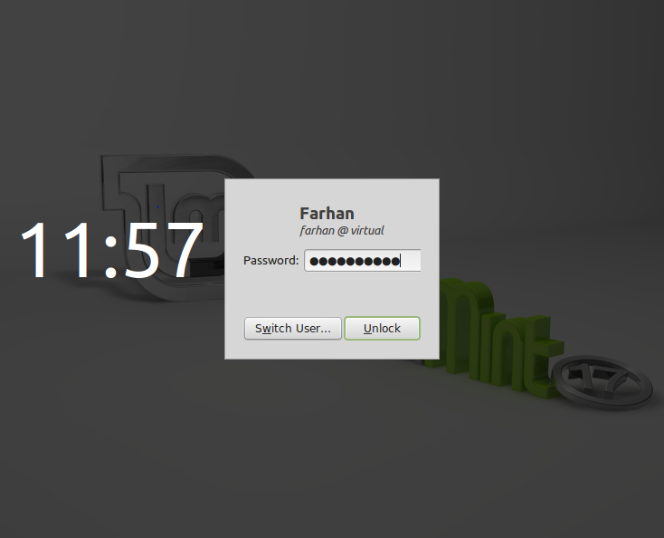

**Step 11: Desktop screen.**

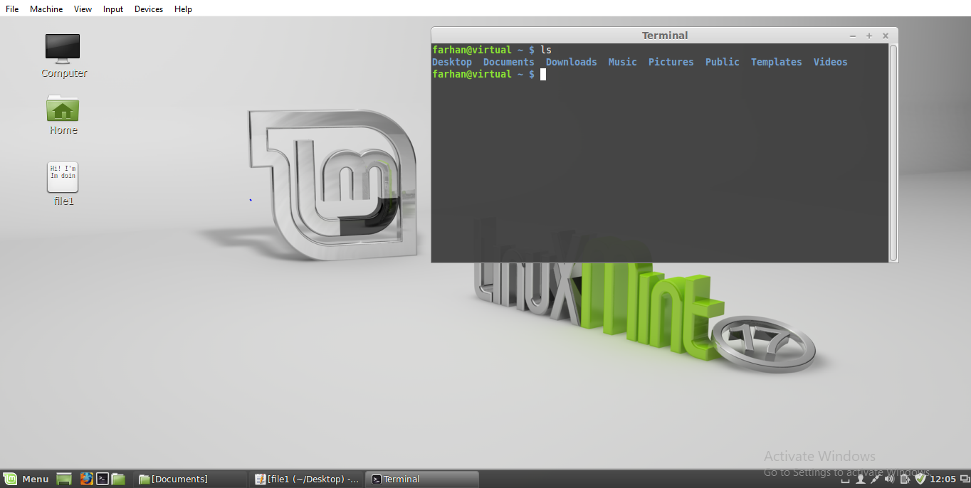

**Conclusion:**

**We can choose Linux as the Operating System for our pc. This more light and secured than the other operating system. So we can easily use Linux. It will give us different test. It is perfect for the professional. And Linux doesn’t need any license, so it is free of cost. And all software for Linux is free. So I think that everyone will enjoy it.**